
PMG 4101: Project Management
Assignment
Project Management in the Field of Artificial Intelligence
A Case Study of NVIDIA Corporation
Submitted by: Group 6
Name | Student ID
Md Jahidul Islam Jony | 0112330060
Sourav Saha | 0112330638
Saptarshi Biswas Supty | 0112330221
Partha Protim Podder | 0112331079
Mahin Hasan Upol | 0112230520
Submitted to:
Syed Samin Sadaf
Lecturer, Dept. of CSE
Date of Submission: 07/10/2026

Table of Contents
1. Introduction 3
2. Company Details 3
3. Project Details 4
3.1 What NVIDIA Sells 4
3.2 The Internal Project Studied 5
4. AI Workflow for the Project Management 5
4.1 Leadership Mandate and Goal setting 6
4.2 Phased Expansion Across the SDLC 6
4.3 Team-Level Ownership and Customization 6
4.4 Context-Aware Automation 6
4.5 Governance and Human Oversight 6
4.6 Reported Effectiveness 7
4.7 Mapping the Workflow to Project-Management Roles 7
5. Pros and Cons 8
5.1 Pros 8
5.2 Cons and Open Questions 8
5.3 Recommendations for Organizations Considering a Similar Rollout 9
6. Conclusion 9
References 10

1. Introduction
This report examines how project management principles are applied to artificial intelligence initiatives inside a real technology company, NVIDIA Corporation. Rather than analyzing a customer-facing AI product, the report focuses on an internal engineering project: NVIDIA's company-wide adoption of an AI coding agent across its software development lifecycle (SDLC). This choice reflects one of the workflow options suggested in the assignment brief examining how a company integrates AI into its own internal projects, in this case through coding agents and workflow automation.
NVIDIA is a useful subject for this analysis for two reasons. First, it is the company most closely associated with the current wave of AI infrastructure, making its own internal practices a natural point of interest. Second, NVIDIA has publicly documented, through a named customer case study, how it restructured its engineering workflows around an AI tool, which gives this report verifiable, citable detail rather than speculation.
The remainder of this report is organized as follows: Section 2 introduces NVIDIA as a company; Section 3 describes the specific internal project studied; Section 4 explains the AI-assisted project management workflow NVIDIA put in place; Section 5 evaluates the pros and cons of that approach; and Section 6 concludes with the broader lessons this case offers for project management in AI-driven organizations.
A note on sources and objectivity: the headline performance figures in this report - the 30,000-developer adoption number and the reported 3x increase in code volume - originate primarily from a case study published by Cursor (the AI coding tool vendor), corroborated by independent technology-press coverage. These are self-reported, vendor-adjacent figures rather than independently audited results, and this report treats them accordingly, flagging that limitation explicitly in Section 5 rather than presenting the numbers as unquestioned facts.

2. Company Details
NVIDIA Corporation was founded on April 5, 1993, by Jensen Huang, Chris Malachowsky, and Curtis Priem, and is headquartered in Santa Clara, California. Originally established to bring 3D graphics acceleration to personal computers, the company introduced the modern GPU in 1999 and its CUDA parallel-computing platform in 2006, decisions that positioned it to become the dominant hardware and software provider for artificial intelligence workloads two decades later.
As of fiscal year 2026, NVIDIA reported revenue of $215.9 billion and net income of $120.1 billion, employed approximately 42,000 people across 38 countries, and reached a market capitalization of roughly $5 trillion, making it the first company in history to cross that threshold and the most valuable publicly traded company in the world. Jensen Huang remains CEO, making him one of the longest-serving founders-CEOs in the technology industry.
Table 1: NVIDIA company snapshot
Founded | April 5, 1993, in Santa Clara, California
Founders | Jensen Huang, Chris Malachowsky, and Curtis Priem
CEO | Jensen Huang — Founder, President & CEO since inception
Headquarters | 2788 San Tomas Expressway, Santa Clara, California
Employees (FY2026) | Approximately 42,000, across 38 countries
FY2026 Revenue | $215.9 billion (up 65% year-over-year)
FY2026 Net Income | $120.1 billion
Market Capitalization | Approximately $5 trillion — the first company to reach this milestone (mid-2026); world's most valuable public company
Stock Listing | NASDAQ: NVDA
Primary Business | Design of GPUs, AI accelerators, networking hardware, and the CUDA software platform

NVIDIA reports two operating segments — Compute & Networking, and Graphics — and serves four principal markets: data centers, gaming, professional visualization, and automotive. Over the past three years, the company's center of gravity has shifted decisively toward AI infrastructure: data-center products now account for approximately 92% of total revenue, up from a much smaller share before the generative-AI boom.

3. Project Details

3.1 What NVIDIA Sells
Before examining the internal AI project, it is useful to summarize what NVIDIA actually builds, since the internal project studied here exists to support the engineering teams that build these products.
Table 2: NVIDIA products and platforms
GPUs | Graphics processing units spanning gaming, professional visualization, data-center, and automotive applications.
CUDA | A parallel-computing software platform and programming model used by more than 7.5 million developers to build and train AI models on NVIDIA hardware.
Data Center / AI Infrastructure | Full racks of GPUs, high-speed networking (NVLink, InfiniBand, Spectrum-X), and systems software sold to cloud providers and enterprises; this segment now generates roughly 92% of NVIDIA's revenue.
NVIDIA AI Enterprise / NeMo / NIM | Software layers for building, deploying, and managing AI agents and generative-AI applications on top of NVIDIA hardware.

3.2 The Internal Project Studied
The project examined in this report is not a customer product but an internal initiative: in 2025, NVIDIA's engineering leadership set a company-wide mandate to embed AI assistance into every phase of its software development lifecycle, using the AI coding agent Cursor (built by Anysphere). This falls squarely into the "coding agents" and "workflow management" categories suggested by the assignment brief.
According to Wei Luo, NVIDIA's Vice President of Engineering, the explicit goal was described as embedding AI in every step of the SDLC — not treating it as a convenience for a subset of developers, but as standard infrastructure for the entire engineering organization. NVIDIA had previously experimented with other AI coding tools, both internally built and third-party, but reports a marked jump in engineering velocity specifically after standardizing on Cursor.
The scope of the rollout is substantial: more than 30,000 NVIDIA developers reportedly use the tool daily, spanning nearly all of NVIDIA's product lines and their large, tightly interdependent codebases, some of which have been under continuous development for over three decades.
It is worth being explicit about what "project" means in this context. NVIDIA does not run this as a single time-boxed project with a fixed end date; it is closer to a continuous program with a permanent mandate, its own leadership, staged milestones, and an evolving scope. Framing it this way matters for the analysis in Section 4, because the project-management techniques NVIDIA applies — chartering, phased rollout, decentralized ownership, and a standing scorecard - are the same techniques used to manage any large, multi-year organizational change program, not techniques unique to software or to AI.

4. AI Workflow for the Project Management
NVIDIA's approach to managing this AI rollout mirrors conventional project-management discipline — a clear mandate, phased execution, defined ownership, and measurable success criteria — applied to the adoption of an AI tool rather than to a traditional deliverable. Viewed through a standard project-management lens, the initiative touches four classic areas of practice: scope management (deciding which SDLC stages to automate and when), stakeholder management (aligning engineering leadership, individual teams, and new hires around a shared tool), risk management (guarding against quality regressions as volume rises), and benefits realization (defining what "success" means well enough to measure it). The workflow itself can be broken into five stages, described below.
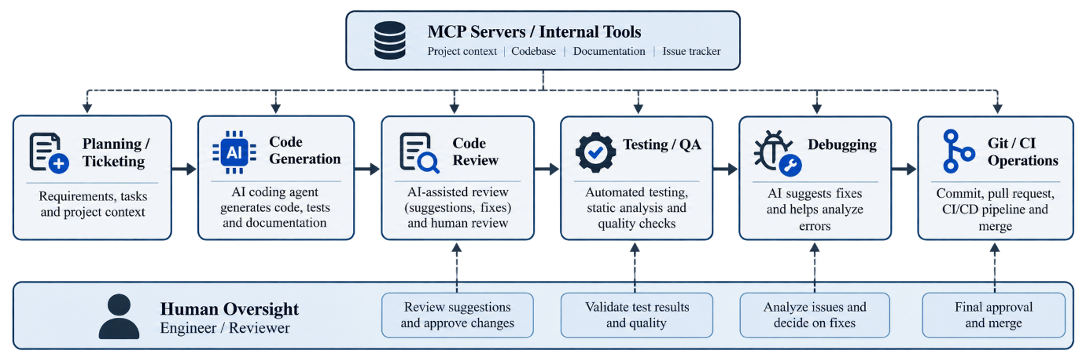
Figure 1: NVIDIA AI-assisted software development workflow

4.1 Leadership Mandate and Goal setting
The initiative began with an explicit engineering mandate from leadership rather than a bottom-up, opt-in experiment. This mirrors a standard project-management practice: defining a sponsor-backed objective before allocating resources. The stated goal “embed AI in every step of the SDLC" - functioned as the project's charter.

4.2 Phased Expansion Across the SDLC
Adoption did not begin everywhere at once. NVIDIA first focused on code generation, the most immediate and visible use case. As developers began shipping code faster, project leadership observed that bottlenecks simply moved downstream to code review, testing, and debugging — a classic project-management insight that optimizing one stage of a pipeline exposes constraints elsewhere. Engineering leadership then deliberately extended the tool's use into those later stages, rather than declaring victory after the first win.

4.3 Team-Level Ownership and Customization
Rather than mandating one rigid workflow for the entire organization, individual engineering teams were given latitude to build their own automation on top of the shared tool. For example, one team automated its git workflow end-to-end — branch creation, commits, continuous-integration debugging, and issue tracking — through custom rules. This decentralization allowed teams closest to the work to design the specific automations most relevant to their codebase, while still operating under the shared company-wide mandate.

4.4 Context-Aware Automation
A more advanced pattern combined the coding agent with Model Context Protocol (MCP) servers to pull relevant context directly from tickets and internal documentation. In this pattern, an automated workflow begins with a bug report or ticket, retrieves the relevant context, has the agent implement a fix, and then runs tests to validate the change before it reaches a human reviewer. This represents a shift from AI as an individual productivity aid to AI as a program-level automation layer.
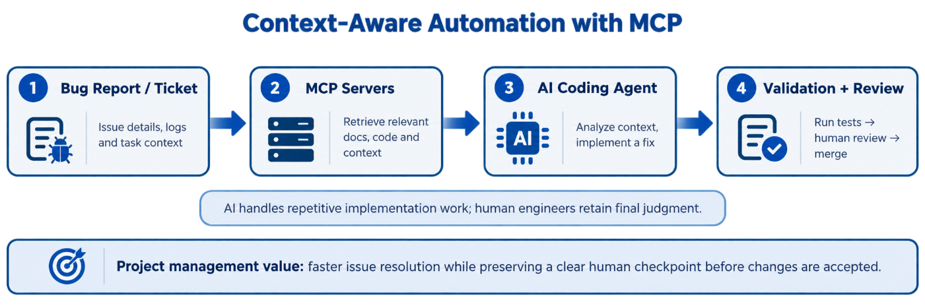
Figure 2: Context-aware automation using MCP servers

4.5 Governance and Human Oversight
Despite the scale of automation, NVIDIA's own description of the rollout emphasizes that software development remains directed and reviewed by humans; AI is positioned as removing bottlenecks and inconsistency rather than replacing engineering judgment. Success is tracked against three explicit categories of metrics: adoption (how many developers use the tool daily), velocity (how much code is produced), and quality (whether bug rates and consistency hold up as output increases) — a structure that resembles a standard project scorecard used to track any major initiative.
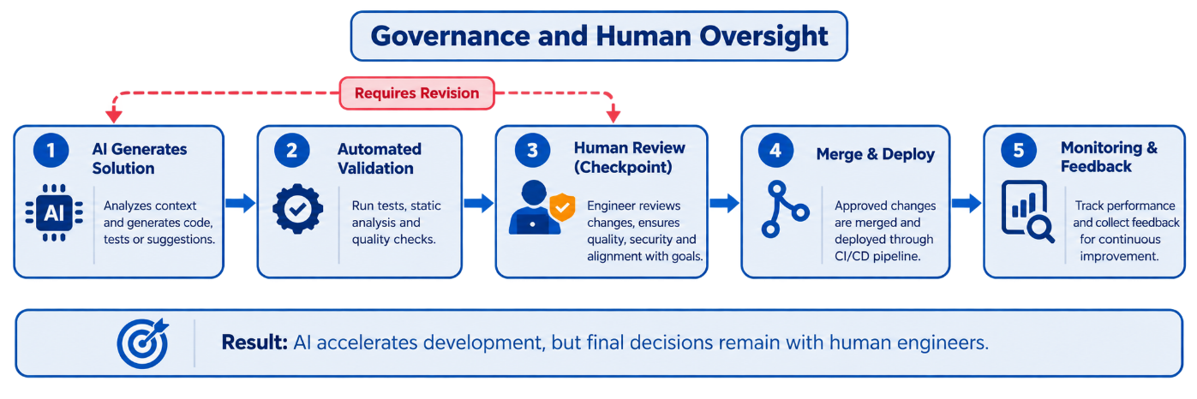
Figure 3: Governance and human oversight in the AI-assisted workflow

4.6 Reported Effectiveness
The table below summarizes the metrics NVIDIA and its tooling vendor report publicly. As discussed further in Section 5, these figures are self-reported and should be read as claimed outcomes rather than independently verified results.
Table 3: Reported effectiveness metrics
Metric | Result | Interpretation
Adoption | 30,000+ daily users | One of the largest publicly reported enterprise rollouts of an AI coding agent.
Coding velocity | 3x more code committed | Measures throughput, not necessarily value delivered or software quality.
Code quality | Bug rate flat; style consistent | Self-reported by NVIDIA and its vendor; not independently verified.
Onboarding | Faster ramp time for new hires | Suggests the tool lowers the cost of NVIDIA's large, complex, 30-year-old codebases.

4.7 Mapping the Workflow to Project-Management Roles
The table below maps each SDLC stage NVIDIA automated to the party responsible for it and the point at which a human remains in the loop. This kind of stage-by-stage ownership map is a standard project-management artifact (comparable to a RACI chart) and is useful here because it shows that AI involvement is not uniform across the pipeline — it is deepest where the work is repetitive and well-specified, and shallowest where judgment calls remain.

Table 4: Mapping the AI workflow to project-management roles
SDLC Stage | Primary AI Role | Human Checkpoint
Planning / ticketing | Pulls context from tickets and documentation via MCP servers | Engineer defines or approves the ticket/task
Code generation | Writes new code across product lines | Engineer reviews and edits before commit
Code review | Flags issues, suggests changes | Reviewer approves or requests further changes
Testing / QA | Generates test cases, runs validation | QA/engineer signs off on test coverage
Debugging | Identifies and proposes fixes for rare or persistent bugs | Engineer validates the fix before merge
Git / CI operations | Automates branch creation, commits, CI debugging | CI pipeline gates merges on passing checks

5. Pros and Cons

Pros
• End-to-end scope: the initiative addresses the entire SDLC — coding, review, testing, and debugging — rather than optimizing a single stage in isolation, reducing the risk that gains in one area simply shift bottlenecks elsewhere.
• Suited to complex legacy environments: NVIDIA's codebases are large, interdependent, and up to three decades old; the tool is reported to perform well specifically because it can retrieve and reason over this scale of complexity, rather than only helping with small, greenfield projects.
• Faster onboarding and cross-skilling: new hires reportedly reach productive contribution sooner, and experienced engineers are able to work confidently outside their usual specialty (for example, backend engineers contributing to frontend code).
• Reported quality stability: NVIDIA states that bug rates held flat even as code volume roughly tripled, and that code-style consistency improved — a meaningful claim if accurate, since a common fear with AI-assisted coding is that higher volume simply produces more defects.
• Clear governance structure: the rollout was managed with an explicit mandate, phased expansion, and named success metrics, which is a stronger project-management foundation than an ad hoc, ungoverned tool rollout.

5.2 Cons and Open Questions
• Source independence: the headline statistics (30,000 daily users, 3x code volume, flat bug rates) come primarily from a case study published by Cursor, the vendor selling the tool, and are echoed by secondary technology-press articles rather than by an independent audit or peer-reviewed study. Vendor case studies are marketing materials by nature, and readers should treat the figures as NVIDIA and Cursor's own claims rather than externally verified facts.
• Volume is not the same as value: a three-fold increase in committed code is a throughput metric, not a direct measure of software quality, user value, or business outcomes. More code could reflect genuine productivity gains, but it could equally reflect more verbose or duplicated code.
• Vendor concentration risk: standardizing a 42,000-person engineering organization's core workflow on a single external AI vendor creates dependency risk — pricing changes, service disruptions, or a change in the vendor's product direction could have an outsized operational impact.
• Oversight of autonomous automation: as agents are given more autonomy — for example, automations that pull ticket context, implement fixes, and run tests with limited human involvement in the loop — questions arise about code review rigor, security review of AI-authored changes, and accountability when an automated fix introduces a subtle defect that flat aggregate bug-rate metrics might not immediately reveal.
• Generalizability: NVIDIA is an extremely well-resourced company with dedicated engineering-productivity leadership; its results may not transfer directly to smaller organizations with less capacity to build custom tooling and governance around an AI coding agent.

5.3 Recommendations for Organizations Considering a Similar Rollout
Based on the strengths and gaps identified above, three practical recommendations follow for any organization - student teams included - evaluating a similar AI-assisted project management approach.
• Separate the vendor's marketing narrative from internal measurement. Treat published case-study figures as a hypothesis to validate against an organization's own before/after data, not as a guaranteed outcome.
• Track quality metrics with as much rigor as velocity metrics. A scorecard that reports adoption and code volume prominently but summarizes quality as a single flat trend line likely understates risk; severity-weighted defect tracking and security-review outcomes should be reported with equal visibility.
• Keep human review load visible as a metric in its own right. If AI increases the volume of code or changes flowing into review and testing, the time reviewers spend per change - and whether that time is shrinking in a way that signals rubber-stamping - is itself a leading indicator worth managing, not just a side effect.

6. Conclusion
NVIDIA's rollout of an AI coding agent across its engineering organization illustrates how project management principles extend naturally into AI adoption: a sponsored mandate, phased execution informed by observed bottlenecks, decentralized but accountable ownership at the team level, and a defined scorecard spanning adoption, velocity, and quality. Viewed this way, the initiative is less a story about a single tool and more a case study in managing organizational change at scale.
At the same time, a careful reading of the available evidence requires some skepticism. The most striking figures come from a vendor-published case study rather than independent verification, and a large increase in code output is not, by itself, proof of better software or better business outcomes. A rigorous project manager evaluating this initiative would want to see the underlying metrics - defect rates by severity, cycle time, developer satisfaction, and security-review outcomes - validated internally over a longer horizon before treating the reported results as conclusive.
The broader lesson for project management in the field of artificial intelligence is that successfully deploying AI tools at scale depends less on the sophistication of the AI itself and more on the surrounding management discipline: clear ownership, staged rollout, measurement against multiple dimensions of success, and retained human governance over the process the AI is embedded within.

References
[1] Cursor (Anysphere, Inc.). “NVIDIA commits 3x more code across 30,000 developers with Cursor.” Cursor, February 6, 2026. cursor.com/blog/nvidia.
[2] Kothiyal, Prachi. “How Nvidia Tripled Code Output with AI – Without Increasing Bug Rates.” Talent500 Blog, February 13, 2026. talent500.com/blog/nvidia-ai-coding-3x-code-output-cursor.
[3] NVIDIA Corporation. Fiscal Year 2026 public financial disclosures (revenue, net income, employee count, market capitalization).
[4] NVIDIA Newsroom and NVIDIA Blog. Company and product information accessed September 2026.

